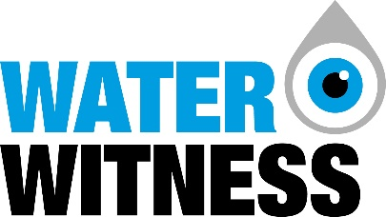

International Programme Officer
Appointment Brief
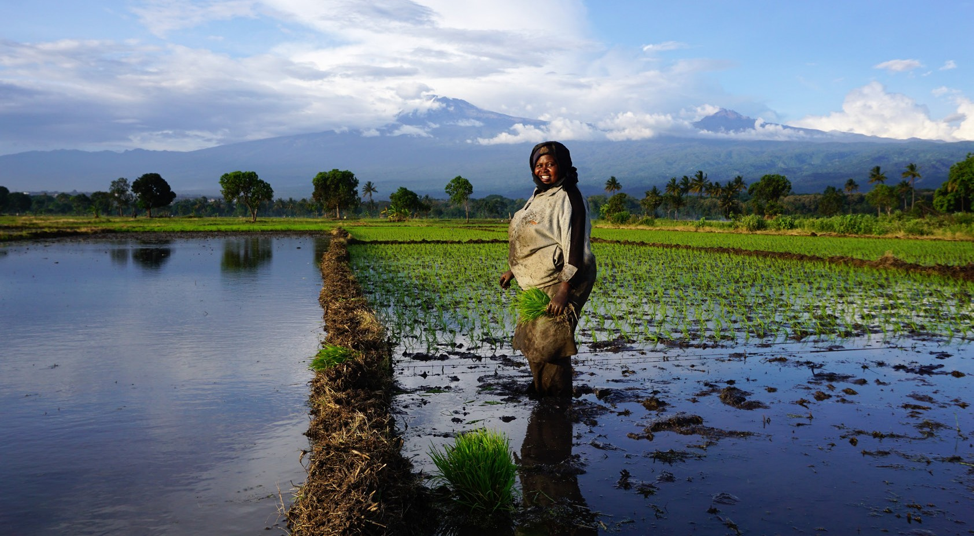
March 2024
Fair Water Future
Action for a

WATER WITNESS INTERNATIONAL PROGRAMME OFFICER | CANDIDATE PACK
Background
3
Job Summary
and Purpose
4
Key working
relationships and logistical arrangements
5
How to Apply
7
The Role
4
Duties and
Responsibilities
5
Person
Specification
6

Contents

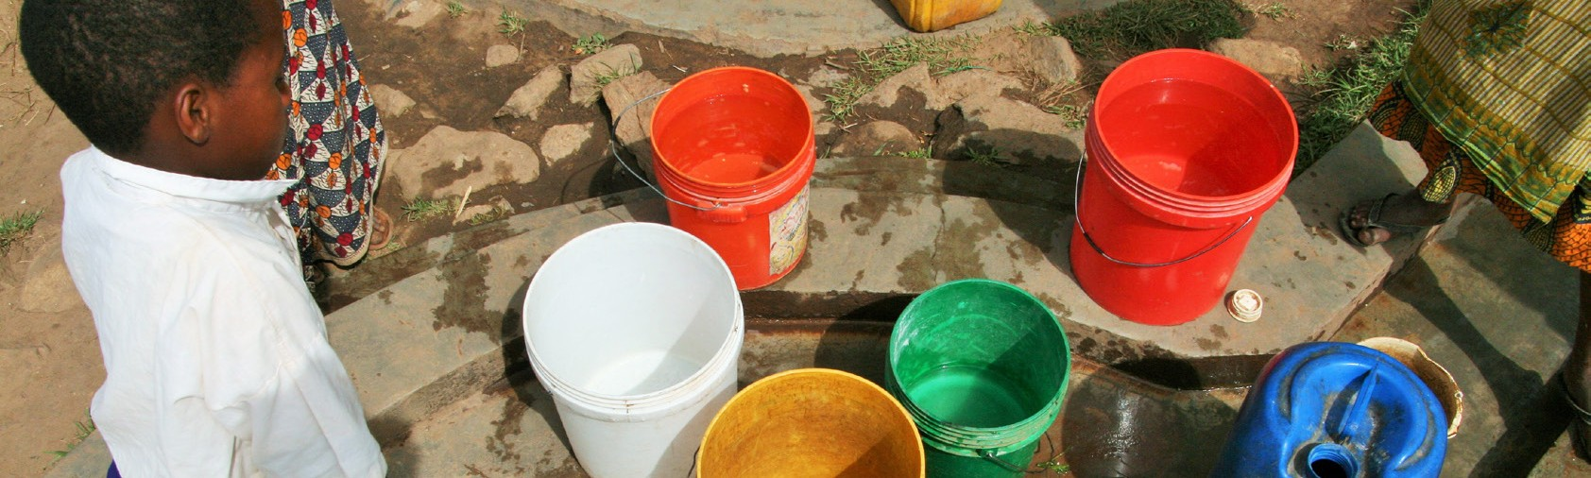

INTERNATIONAL PROGRAMME OFFICER | CANDIDATE PACK
WATER WITNESS

Background

Water Witness leads action, research and advocacy for a fair water future where all people can access the water needed to thrive, and are protected against floods, drought, pollution, ecosystem degradation and water conflict.
We stand with those at the sharp end of the global water crisis to shine a light on its impacts, to understand its root causes and to activate an effective response. We work with inspirational local partners to trigger social justice and system change to ensure sustainable management and equitable use of the world’s most precious resource.
Over the past decade our team have been on the frontline: working to improve water security for over 1 million vulnerable people, driving improved policy, practice and investment, building new approaches and communities of practice, and holding duty bearers to account for improved performance on water. Our hands-on field experience is backed up by cutting-edge research and global analyses, and this provides us with a clear understanding of the action needed to deliver on the water-related Sustainable Development Goals.

Our new 2030 strategy builds on our track record as a dynamic NGO which unlocks improved water resource governance and water security for vulnerable communities. In the decade ahead we will work with our partners to focus on the following five imperatives:

- Accountable governance: to implement effective and equitable water policy and law
- Progressive financing: to unlock funding and financial incentives for water security
- Redefining corporate responsibility: to transform private sector behaviour for shared water security
- Confronting climate chaos: to prevent catastrophic water shocks and build resilience
- Activating people power: to trigger political, social and economic change for water security

We are now seeking exceptional individuals with the skills and experience needed to deliver on our Strategy and the opportunities for positive change ahead.
WATER WITNESS INTERNATIONAL PROGRAMME OFFICER | CANDIDATE PACK

The Role

Job Title: Place of Work: Pay:
Reports to: Travel: Term:

International Programme Officer
Edinburgh, UK
£32,145 - £35, 531, UK Scale 3 (plus benefits including 8% employer pension contribution).
Deputy Director
This post requires international travel, including to remote locations (indicative up to 14 weeks each year)
Initial 16-month contract, extension subject to performance and funding

Job Summary and Purpose

Water Witness International is seeking an international development practitioner, with a technical background in water and environmental management, to support our growing portfolio of work to secure lasting water security and justice for some of the world’s most vulnerable communities.

From our headquarters in Edinburgh the postholder will respond to the evolving support needs of our partners globally and ensure that the evidence emerging from their work drives positive change locally, and systemic change at scale. Specific responsibilities will include the design, launch and operation of the SDG6 Accountability Facility – a long term initiative to channel financial, technical and legal support to those working for water justice on the front line of the global water crisis. Regular extended missions will be required to support accountability monitoring and investigations that are effectively planned, resourced, delivered and documented. The International Programme Officer will work closely with the Africa Programme Manager, Senior Leadership Team to help deliver our wider strategy.

We are looking for an exceptional individual who has a solid technical understanding of the issues and experience in forming effective relationships with international partners, ensuring joint ownership and positive impact. The post holder will support sub-granting to partners, coordinate monitoring, evaluation and learning, programme planning, oversight, problem solving and reporting, as well as external liaison and programme communications.

The post holder will require exceptional organizational, analytical as well as written and oral communication skills, and will have the experience, energy and confidence to build on our position of influence. With an excellent work environment, renumeration and benefits package, this is an exciting opportunity for a future global leader on water and development to drive real change at the cutting edge of sustainable development and social justice.
.

WATER WITNESS INTERNATIONAL PROGRAMME OFFICER | CANDIDATE PACK

Duties and responsibilities

The objective of this role is to work closely with our country partners to ensure the effective launch, operation and growth of the SDG6 Accountability Facility, which will channel support to civil society, media and research partners working for water justice in the Global South. The International Programme Officer will be responsible for the joint preparation and delivery of work-plans and for ensuring that tracking, monitoring, evaluation and learning support impactful delivery in line with donor agreements and budgets. The post holder will work together with and support the country teams to analyse, package and deliver external learning, advocacy and communications, and to coach and mentor others across the accountability monitoring cycle.

Specific responsibilities will include:

Programme coordination, monitoring, evaluation and reporting
  - Contribute to organisational and programme planning against agreed delivery targets, outputs and outcomes.
  - Prepare high quality, timely reports to partners including progress against M&E indicators and suggest and deliver proactive management interventions to keep work on track and maximise impact.
  - Support country teams to strengthen and implement effective MEAL systems.
  - Track and support delivery of workplans and resources, proactively seizing opportunities and troubleshooting problems.
  - Support country partners to ensure social inclusion where the needs of vulnerable people are clearly heard and acted upon.
  - Support effective communication with the UK team, across in-country teams and with partners.
  - Monitor financial and material resources relevant to project needs, flagging any concerns to the line manager and UK Business Manager.
  - Champion learning with grantees, ensuring learning emerging from their work is focused on driving systems change.

Technical delivery and quality assurance
  - Provide technical advice and support potential/actual grantees with design and delivery of accountability monitoring, investigations and assessments on all aspects of water security (pollution, water access, drought and flood response, WASH access).
  - Mentor and support field teams to ensure high quality delivery and documentation including writing and reviewing of programme reports that reflect impact and advocacy materials.
  - Liaise effectively with stakeholders, negotiate consensus and ensure good documentation and record keeping.
  - Undertake desk studies and literature reviews and produce issue background reports.
  - Support organisational capacity building and training of grantees, including compliance with safeguarding policies and best practice.

Documentation, learning and advocacy
  - Co-develop appropriate methods and guidance to support delivery of key tasks within the accountability cycle (for example field assessments; participatory methodologies; budget analysis; advocacy planning and delivery).
  - Develop, co-author and disseminate knowledge products, including case studies, training modules, and guidance materials in support of programmes, liaising with the Communications and Campaigns Director and Officer.
  - Document and analyse evidence, lessons and insights.
  - Support partners to collate, analyse and synthesise knowledge generated.
  - Create and support targeted delivery of programme outputs to key audiences, including press, multi-media and website content and high impact presentations, liaising with the Communications and Campaigns Director and Officer.
  - Identify opportunities to increase programme visibility and raise the organization’s profile by disseminating results within and beyond the development community and water sector, liaising with the Communications and Campaigns Director and Officer.

Organisational development
  - Represent Water Witness and the interests of its stakeholders at local and international meetings as required and develop strategic relationships with partners.
  - Contribute to the strategic development of the organisation including through developing funding proposals, bids and efficient back-office support and management.
  - Provide advice and support to the Director, staff, partners and the Board of Trustees.
  - Help secure and deliver work assignments globally as required.
  - Help with fundraising proposals as required.

WATER WITNESS INTERNATIONAL PROGRAMME OFFICER | CANDIDATE PACK

Key working relationships and logistical arrangements

The successful applicant will be a key member of our team of 7 professionals based at our Head Office in Edinburgh. They will report to the Deputy Director and will work closely with Africa Programme Manager based in Ethiopia and partners across Africa and globally.

Person Specification

The successful applicant will be able to demonstrate the following:

Experience and qualifications:

Essential
  - Sound technical understanding of water and water resource management, climate resilience and international development issues, trends and priorities.
  - A postgraduate degree in a relevant field (for example, Water, Environmental Science or International Development).
  - Experience of working effectively with teams and diverse stakeholders through participatory processes.
  - Proven experience of programme support, communications and coordination.
  - Experience of planning, monitoring & evaluation and reporting on donor-funded programmes.
  - Experience of working on advocacy programmes and use of multi-media communication strategies.
  - Proven knowledge of financial management and budgeting.
  - At least 4 years of relevant professional experience, with at least 1 year based in the Global South.
  - Right to work and live in the UK.

Desirable
  - Knowledge and experience of grant making and delivery of technical assistance to civil society partners.
  - Experience of working in Africa, Asia and/or Latin America - especially our focal countries - and in cross cultural settings as part of a busy team.
  - Experience of working with the private sector, government, and civil society.

Skills and attributes:

Essential
  - Excellent analytical and writing skills, adapting style to write for a range of audiences.
  - Familiarity and competence in the use of social media, graphic design, film/photography, and publishing.
  - A strong communicator with the ability to listen, respond to, and negotiate with diverse and sometimes challenging audiences.
  - Organisational capability, including the ability to prioritise personal and team workloads in a complex, fast-paced environment.
  - Ability to capture and analyse qualitative and quantitative information and to synthesise it into clear summaries, recommendations and concise reports.
  - Ability to work collaboratively and to coordinate with dispersed international teams comprised of people from diverse backgrounds.
  - Facilitation and training skills, ideally in supporting partners or colleagues internationally.
  - Able to analyse financial information, budgets and monitor costs.
  - Excellent IT skills, particularly in Excel, PowerPoint and Word.
  - Ability to travel overseas and thrive in challenging conditions.
  - A passion for social justice through equitable and sustainable water management.

Desirable
  - Working ability or fluency in an African language.

INTERNATIONAL PROGRAMME OFFICER | CANDIDATE PACK
WATER WITNESS

How to apply

All correspondence should be sent to jobs@waterwitness.org with ‘International Programme Officer’ in the subject line. Please provide a CV and cover letter in ONE single document. The cover letter should be no more than two pages long, must explain why you want to work in this position, and should clearly set out how your skills and experience make you a good fit. To demonstrate your writing capabilities, please also write and attach a paper of no more than 2 sides, properly referenced, on ‘The role of accountability monitoring in improving water security in Africa’.

NOTE: APPLICATIONS WHICH DO NOT MEET THESE REQUIREMENTS WILL NOT BE CONSIDERED

Equality Statement
Equality and diversity are at the core of Water Witness’ values. Staff are expected to work collectively and individually to promote a constructive and sensitive approach to others from a variety of backgrounds, where the work of others is valued and respected. We are committed to equal opportunities for all, and to welcoming people from a wide diversity of backgrounds, cultures and experience. On this occasion only those with an existing right to work and live in the UK should apply.

Selection Process
We’ll only use the information you provide to process your application. For more details on how we use your information, see our applicants privacy notice. By emailing us, you are permitting us to use the information you have provided for recruitment purposes. Shortlisted candidates may be required to undertake an additional assessment prior to final interview.

Timeline

Closing date:
Interviews:
Expected start:

9am 30th April 2024
w/c 13th May 2024
June 2024

Queries
If you have any queries on any aspect of the appointment process, or need additional information, please email jobs@waterwitness.org.

